User Interface (UI) Design for Financial Trading Platforms:
A Review of the Academic Literature with Data Analytics
Authors:
Mohammed | | Hamed | Majid | Omero
Authors Emails:
Mohammed (202031137@uaeu.ac.ae)
Hamed: (202008437@uaeu.ac.ae)
Majid (202219094@uaeu.ac.ae)
Omero (700042090@uaeu.ac.ae)

BANA 420 - Spring 2026

Abstract
This report reviews academic literature related to user interface design for financial trading platforms. The final corpus contains 491 related publications retrieved from SCOPUS, after title-based deduplication and manual removal of unrelated search results. The study combines text mining, bibliometric summaries, VOSViewer network visualization, and bibliometrix-ready analysis outputs to identify the major themes and structure of the literature. Across the abstracts, the most frequent terms emphasize data, trading, systems, markets, financial applications, models, platforms, users, and design. The findings show that the topic is between human-computer interaction and financial technology: one part of the literature focuses on users, platforms, usability, and interface design, while another focuses on market prediction, financial data, blockchain, energy trading, and algorithmic systems. The report also discusses ethical issues in trading-interface design, including algorithmic transparency, interface-induced cognitive bias, data privacy, and accessibility.
Keywords: user interface design, financial trading platforms, usability, human-computer interaction, text mining, bibliometric analysis, VOSViewer, bibliometrix, SCOPUS, financial technology

1. Introduction

1.1 Definition and Scope
User interface design for financial trading platforms concerns the way traders, investors, analysts, and other financial-market participants interact with digital systems for monitoring markets, interpreting information, placing orders, and managing risk. A trading platform is not only a transaction tool; it is also an information environment. It displays prices, charts, order books, portfolio positions, news, alerts, risk indicators, and increasingly algorithmic recommendations. The interface therefore shapes what users notice, how quickly they understand market conditions, and how confidently they act.
This topic draws from human-computer interaction, usability engineering, information visualization, behavioral finance, software engineering, and financial technology. Good design in this domain must support speed and accuracy without encouraging reckless behavior. It must also make complex information understandable without hiding uncertainty or risk. Because trading decisions can lead directly to financial gain or loss, interface design in trading platforms has higher practical and ethical stakes than many ordinary software interfaces.

1.2 Importance of the Topic
The importance of trading interface design has grown as electronic and mobile trading have expanded. Professional traders rely on dense, high-speed interfaces, while retail investors increasingly use simplified apps that make trading feel immediate and accessible. In both settings, design choices can influence decision quality. Confusing layouts may increase order-entry mistakes; poorly designed alerts may encourage impulsive trading; opaque algorithmic signals may create overconfidence; and inaccessible visual conventions may exclude some users.
Academic analysis of this topic is important because financial interfaces combine technical performance with human judgment. A platform may have strong algorithms and data feeds but still fail users if the interface makes information difficult to interpret. At the same time, an attractive and frictionless interface can be harmful if it makes risky trading feel too easy. Studying the literature helps identify what researchers emphasize, where the field is growing, and what gaps remain for future research.

2. Data

2.1 Data Source and Search Strategy
The data were collected from SCOPUS using keyword searches related to trading platforms, user experience, usability, interface design, human-computer interaction, requirements engineering, and decision-support systems. The downloaded SCOPUS export files were combined into a single dataset, then sorted and deduplicated by normalized title. The raw combined file contained 588 search-result rows; title deduplication reduced this to 511 unique records. Manual relevance review then removed 20 unrelated or weakly related records, leaving 491 final publications for analysis.

2.2 Data Fields
Data A contains 28 fields. Key fields include PaperID, search number, source search file, authors, full author names, author identifiers, title, publication year, source title, volume, issue, article number, page range, citation count, DOI, link, affiliations, abstract, author keywords, index keywords, document type, publication stage, open-access status, source, EID, and topic flag. Data B is a reduced file containing only PaperID and abstract text, because the required text-mining analyses are based on the abstract corpus.
- Raw combined SCOPUS rows: 588
- Rows after title deduplication: 511
- Manual-review/unrelated rows removed: 20
- Final related-paper corpus: 491
- Final abstracts available: 491
- Unique publication venues: 384
- Year range: 2015-2026

2.3 Dataset Overview
The final corpus covers publications from 2015 through 2026. It is distributed across 384 publication venues, showing that the topic is interdisciplinary rather than concentrated in a single journal or conference series. The most common document types are Conference paper: 236, Article: 203, Book chapter: 21, Conference review: 14. This distribution reflects the strong role of conference-based computer science and information-systems research alongside journal-based finance, engineering, and HCI research.

3. Methodology

3.1 Required Project Workflow
- Search the academic literature in SCOPUS using topic keywords and download indexed CSV files.
- Combine all search results into one Data A workbook while preserving the search source for each row.
- Sort by title and remove duplicate records.
- Remove unrelated entries after manual relevance review.
- Add a sequential PaperID variable labeled P001, P002, and onward.
- Analyze the abstracts using text mining and a structured GenAI-assisted interpretation prompt.
- Create Data B with only PaperID and abstract text.
- Run the required text-analytics outputs: top terms, word cloud, heatmap, document map, and term map.
- Use VOSViewer for network visualization and graph-based literature mapping.
- Use bibliometrix/biblioshiny-compatible workflows for bibliometric summaries and graph analytics.
- Write the report with title, authors, emails, abstract, keywords, introduction, data, method, analysis/results, conclusions, references, and appendices.

3.2 Text-Mining Procedure
Text mining was performed on Data B, the PaperID-abstract file. Abstracts were tokenized into individual words, converted to lowercase, and cleaned by removing English stop words. A small set of generic academic terms such as paper, study, studies, using, approach, and method was also removed because those words describe scholarly writing rather than the subject matter of financial trading interfaces. The cleaned tokens were counted across the full corpus to identify the top 20 most frequent terms.
For the term-correlation heatmap, each top term was represented as a vector of document-level counts, and Pearson correlations were computed between the vectors. For the document map, abstracts were represented as TF-IDF vectors and projected onto two dimensions using classical multidimensional scaling. For the term map, a distance matrix was derived from term correlations and projected onto two dimensions using the same MDS logic.

3.3 GenAI Use
The project requires using a GenAI tool to support abstract analysis and interpretation. Data B was used as the abstract file for this step. The structured project prompt asked the GenAI tool to interpret five outputs: the 20 most frequent terms, the word cloud, the top-term correlation heatmap, the 2D document map, and the 2D term map. The GenAI output was treated as interpretive support rather than as a substitute for verification. Frequencies, coordinates, and correlations were checked against the generated tables and figures before being incorporated into the report.

3.4 VOSViewer and Bibliometrix
VOSViewer was used for network-style visualization of term and keyword relationships. These maps help reveal clusters of concepts and show whether UI, usability, financial-market, and technology themes appear together or separately. For the bibliometrix component, the final Data A workbook was converted into a bibliometrix-style R data frame with AU, TI, SO, PY, DT, TC, DI, DE, ID, AB, and CR fields. The R bibliometrix package was then used through biblioAnalysis (M, sep = ';') to generate annual scientific production, source productivity, author productivity, keyword, and citation summaries. The affiliation/country field was not used inside biblioAnalysis because the available affiliation strings were incomplete for automatic country extraction; the country-collaboration evidence is instead represented through the VOSViewer country map.

4. Analysis and Results

4.1 Twenty Most Frequent Terms
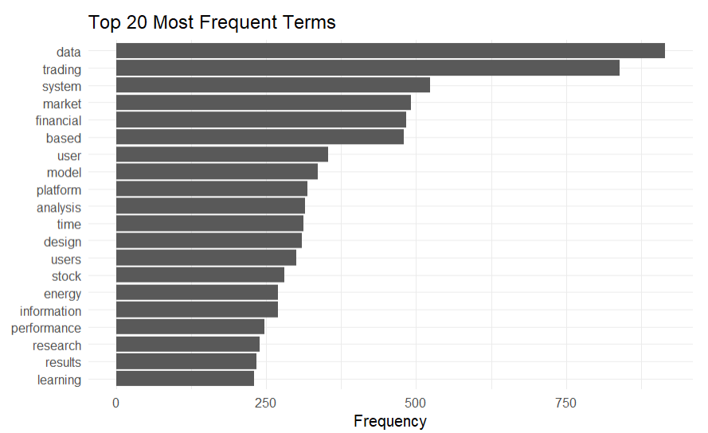
Figure 1. Top 20 most frequent terms in the final abstract corpus.
The most frequent terms are data (881), trading (826), market (484), financial (482), and system (479). This ranking shows that the literature is centered on data-intensive trading systems and financial-market applications. At the same time, the appearance of platform, user, design, and users among the top terms confirms that the corpus is not only about prediction models or market data; it also includes a meaningful interface and human-use dimension.

4.2 Word Cloud
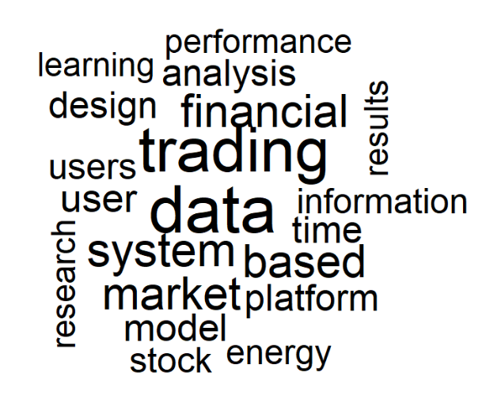
Figure 2. Word cloud of the 20 most frequent terms.
The word cloud provides a quick visual summary of the same frequency pattern. The largest words are data and trading, followed by system, market, financial, model, analysis, platform, user, and design. The visual balance suggests that the field is split between technical-financial concepts and user-facing interface concepts. This split is important because trading-platform design cannot be evaluated only by technical performance; the way people interact with information is also central.

4.3 Correlation Heatmap of Top Terms
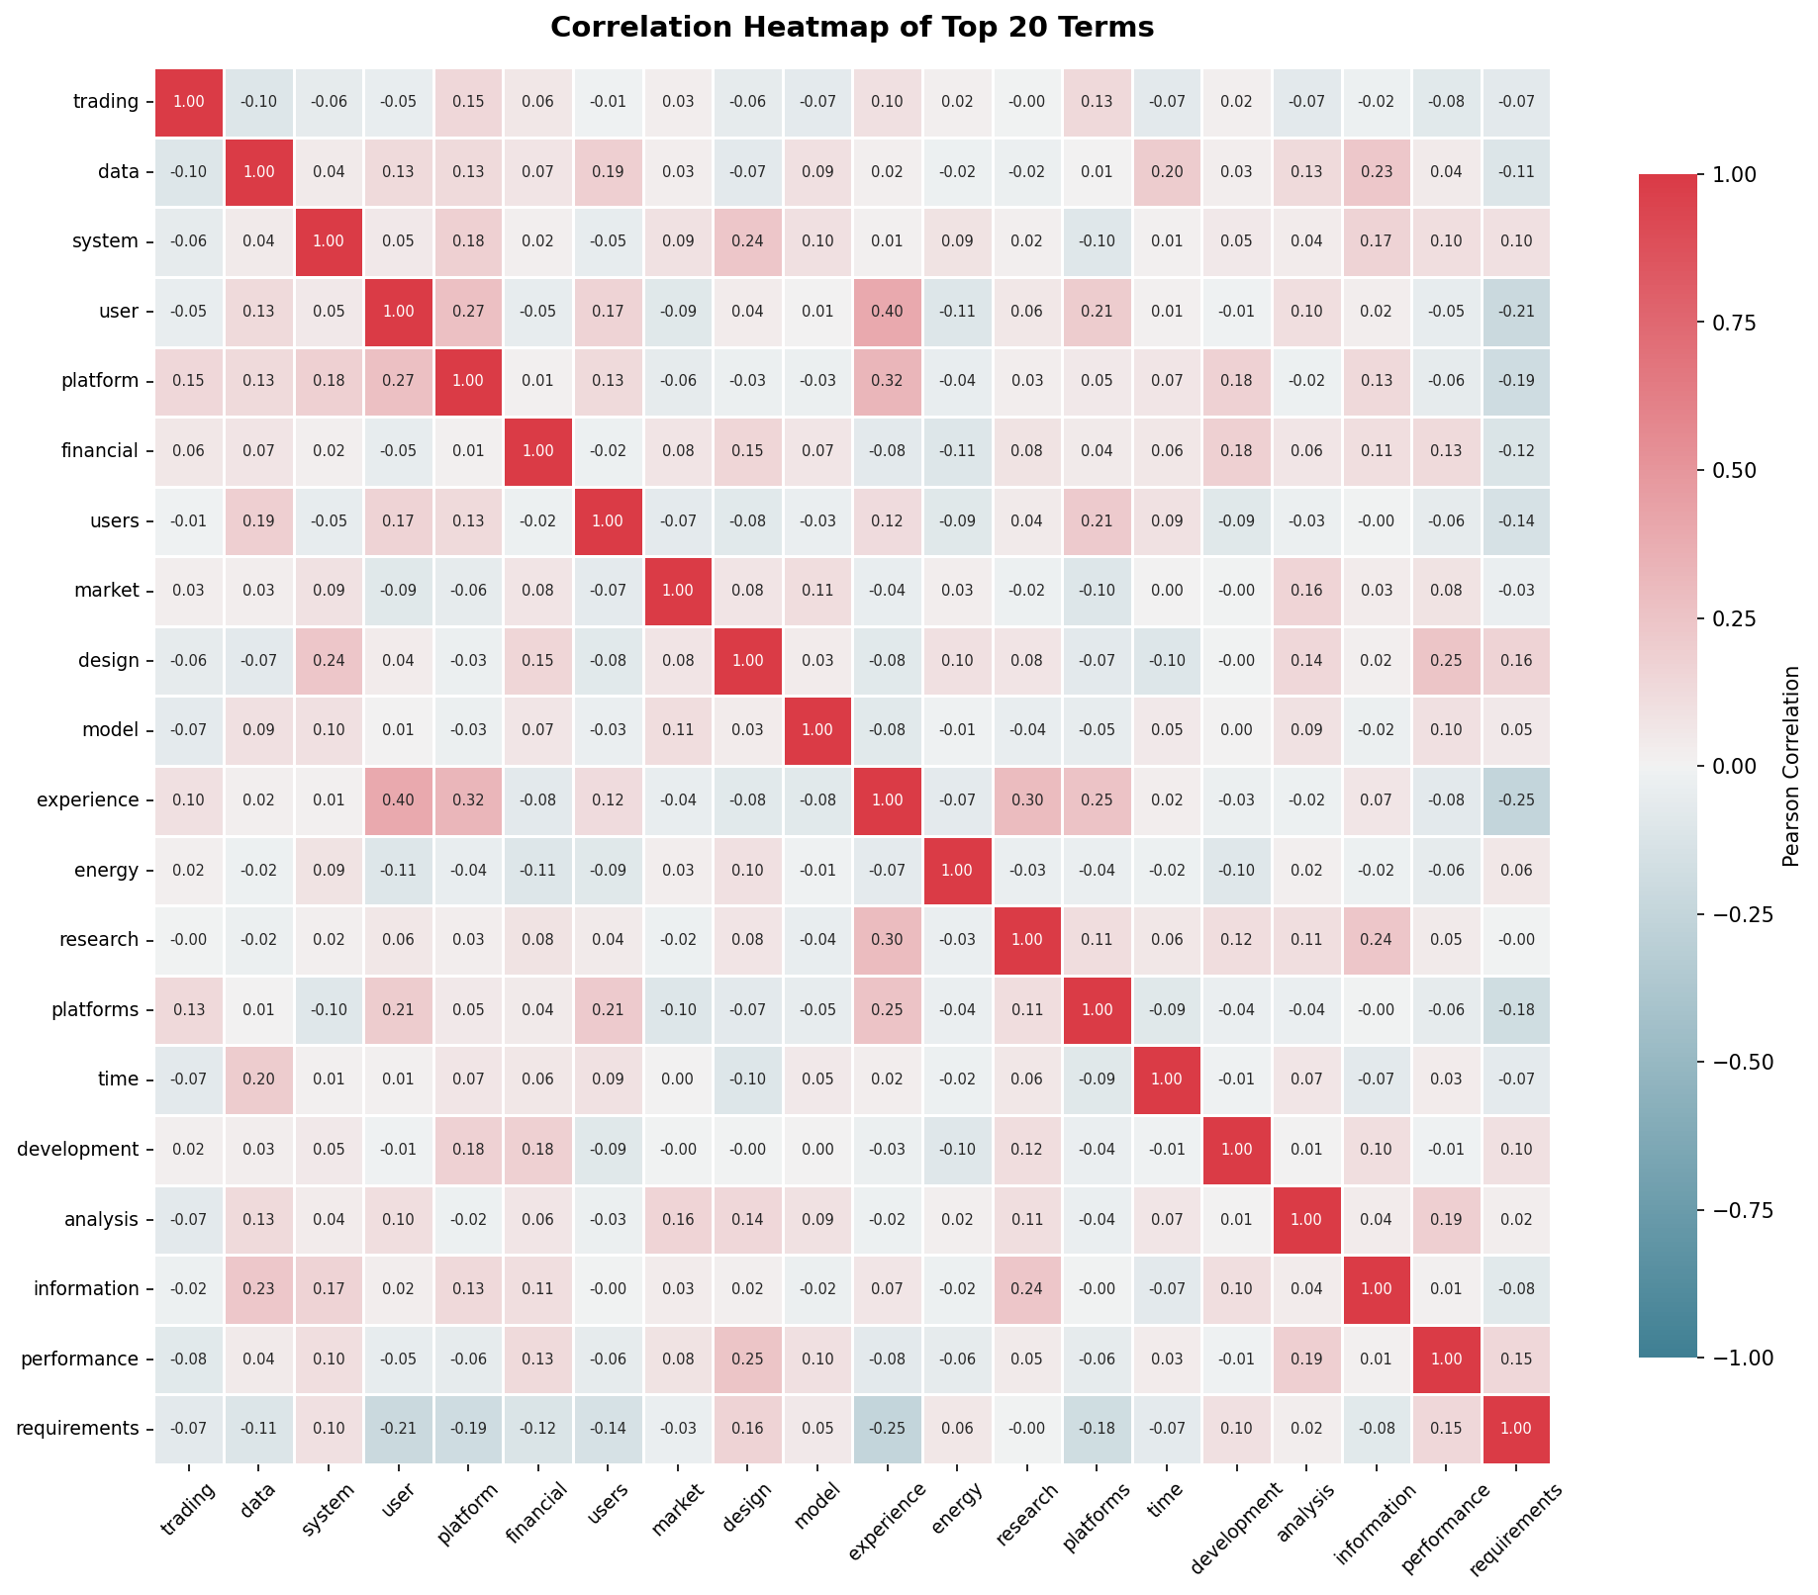
Figure 3. Correlation heatmap of the top 20 terms.
The strongest positive relationships include user-experience (r=0.38), market-stock (r=0.35), platform-experience (r=0.32), data-analysis (r=0.29). These correlations indicate which concepts tend to appear in the same abstracts. Finance-oriented terms such as market, financial, stock, model, and learning tend to group together, while interface-oriented terms such as platform, user, users, design, and information form another related set. The heatmap therefore supports the idea that the literature has two overlapping centers: quantitative/financial systems and human-centered interface design.

4.4 Mapping Documents on a 2D Plane
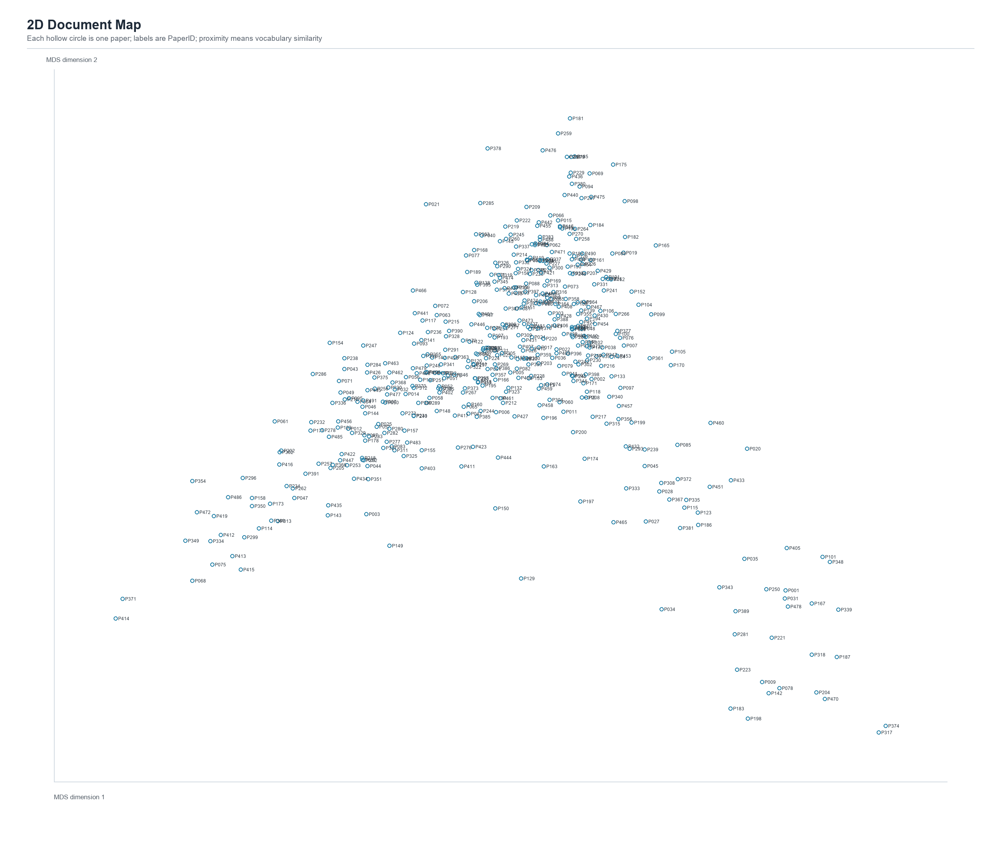
Figure 4. 2D document map. Hollow circles represent papers labeled by PaperID.
The document map positions papers according to abstract similarity. Papers located close to one another use similar vocabulary and are likely to share themes, methods, or application areas. The dense central region suggests a large body of papers with overlapping terminology around data, trading, systems, and markets. The more distant points represent specialized papers, such as those focused on technologies, domains, or design contexts. This map is useful because it shows that the corpus is connected but not uniform: several subtopics exist within the broader area of trading-platform interface research.

4.5 Mapping Terms on a 2D Plane
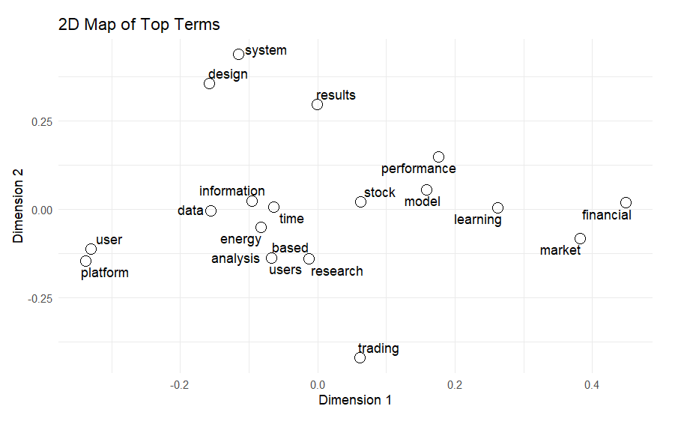
Figure 5. 2D term map. Hollow circles represent top terms labeled by word.
The term map gives a concept-level view of the corpus. Terms positioned near each other tend to co-occur across abstracts, while distant terms appear in different parts of literature. The finance and analytics side of the map is represented by terms such as market, financial, stock, model, learning, and analysis. The interface side is represented by platform, user, users, design, information, and system. This separation is useful for interpreting the field: research on trading platforms often combines technical financial analysis with questions about how users understand and act on information.

4.6 Publication Trend
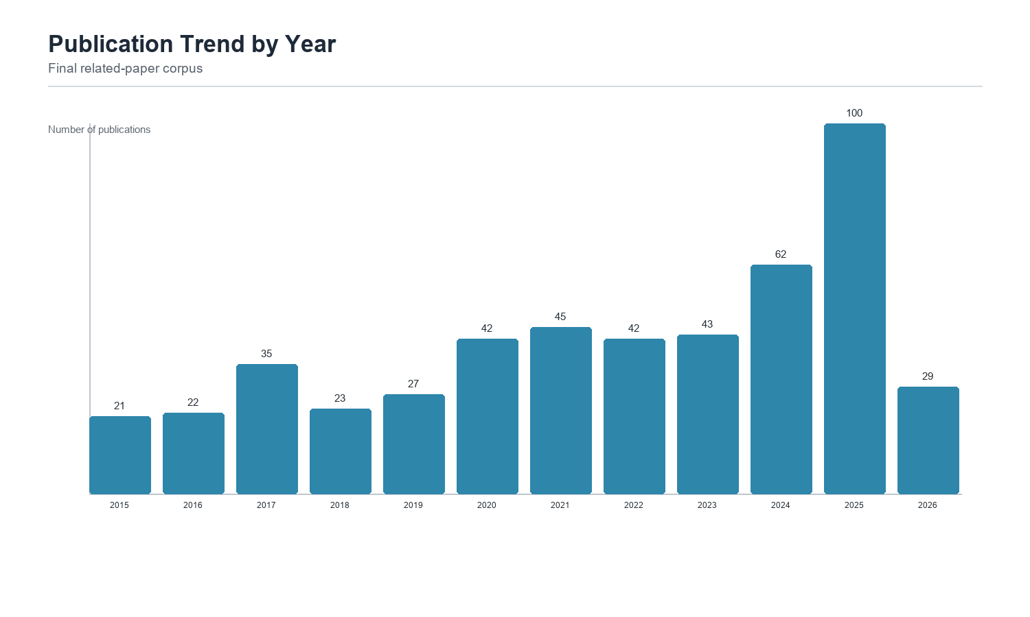
Figure 6. Publications by year in the final related-paper corpus.
Publication activity increases over the study period and reaches its highest observed level in 2025, with 100 publications. The rise after 2020 is consistent with broader growth in financial technology, mobile trading, AI-assisted investment tools, blockchain-based transaction systems, and data-driven market analysis. The partial 2026 count should be interpreted cautiously because the year was not complete when the dataset was collected.

4.7 Publication Venues and Document Types
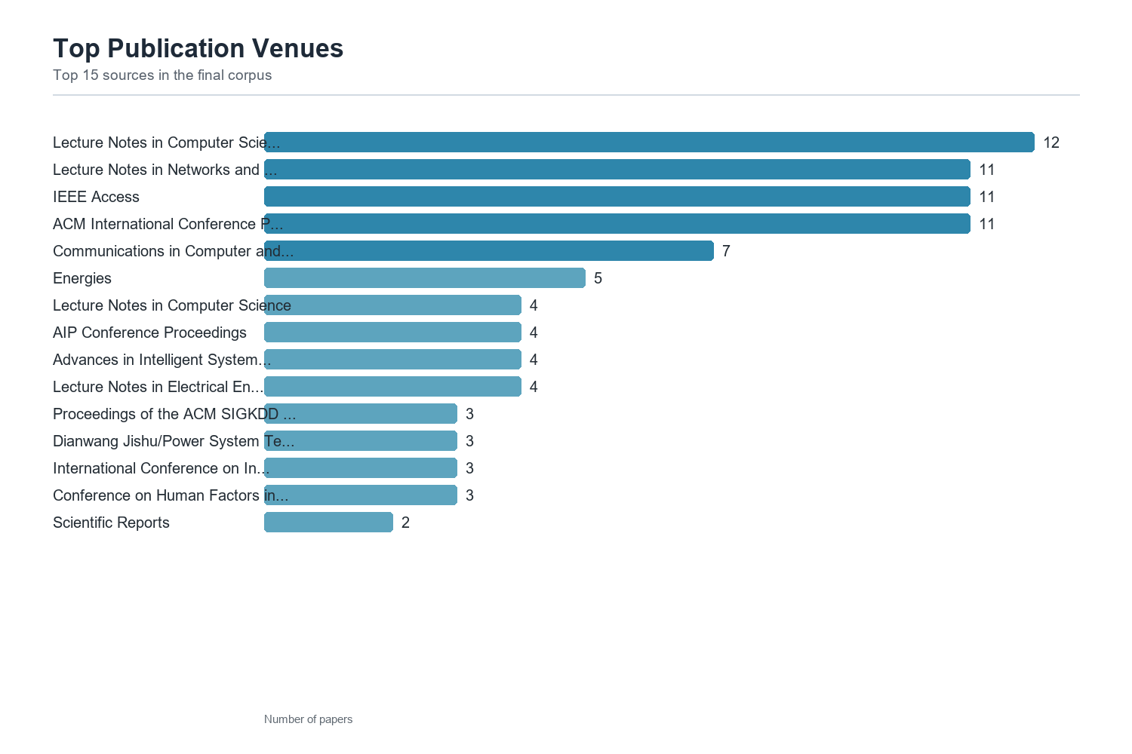
Figure 7. Top publication venues.
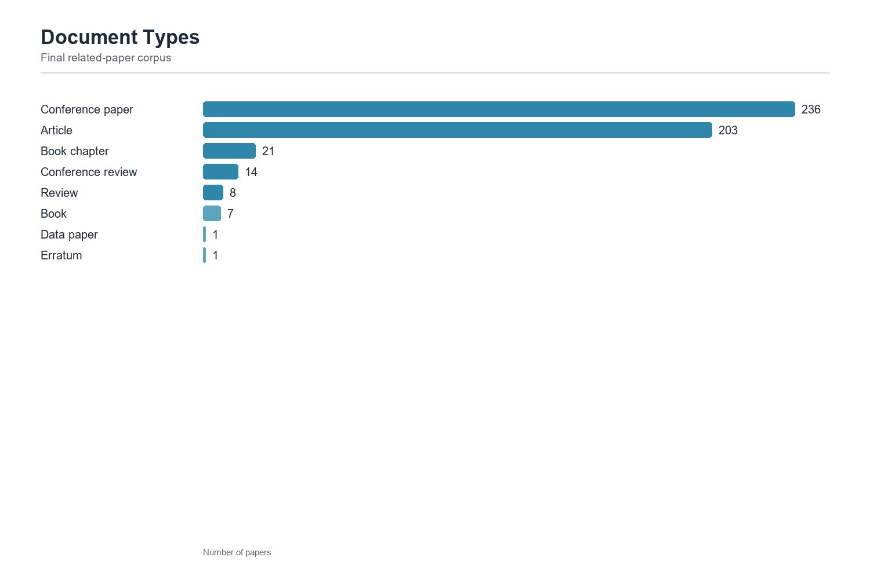
Figure 8. Document type distribution.
The top publication venues show that the topic is spread across computer science, engineering, information systems, finance, and applied technology outlets. Conference papers and journal articles dominate document-type distribution, which is typical for a topic that combines fast-moving software design research with applied financial-technology problems.

4.8 Search Query Distribution
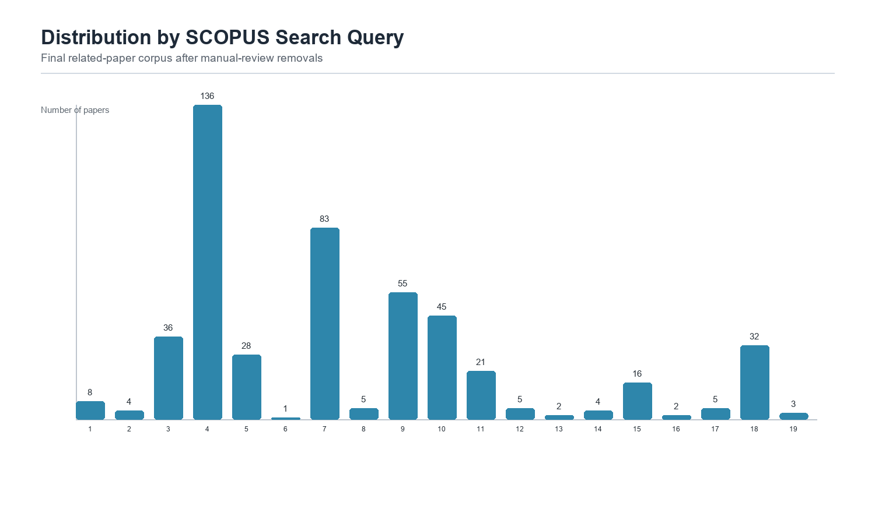
Figure 9. Distribution of papers across SCOPUS search queries.
The search-query distribution shows that broad terms related to trading-platform user experience, electronic trading interfaces, requirements engineering, and interaction design contributed to the largest portions of the dataset. This confirms the importance of combining several search expressions rather than relying on a single query. Narrow queries captured specialized papers, while broader queries captured the main body of literature.

4.9 VOSViewer Network Results
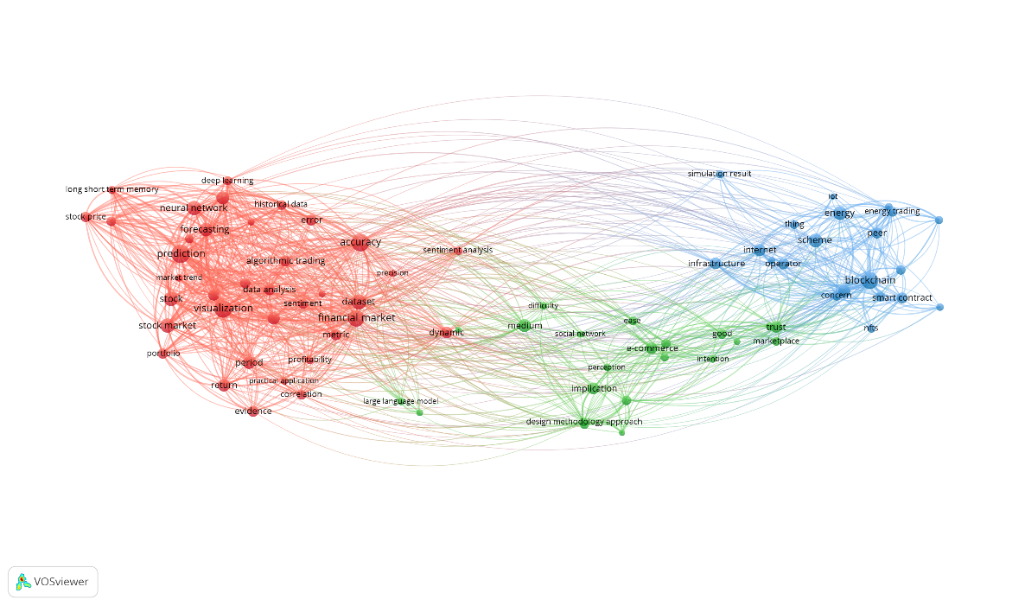
Figure 10. VOSViewer abstract/title term co-occurrence network.
Major terms from the paper titles and abstracts are connected. The largest and most central group is related to prediction, forecasting, stock market, financial market, visualization, dataset, neural network, and accuracy. This suggests that a large part of the literature focuses on data-driven financial prediction and visual analysis. A separate cluster appears around blockchain, smart contract, NFT, energy trading, and peer networks, showing that blockchain-based trading systems form a distinct research theme. Another middle cluster includes terms such as e-commerce, trust, marketplace, intention, and design methodology, indicating user behavior and platform adoption topics.
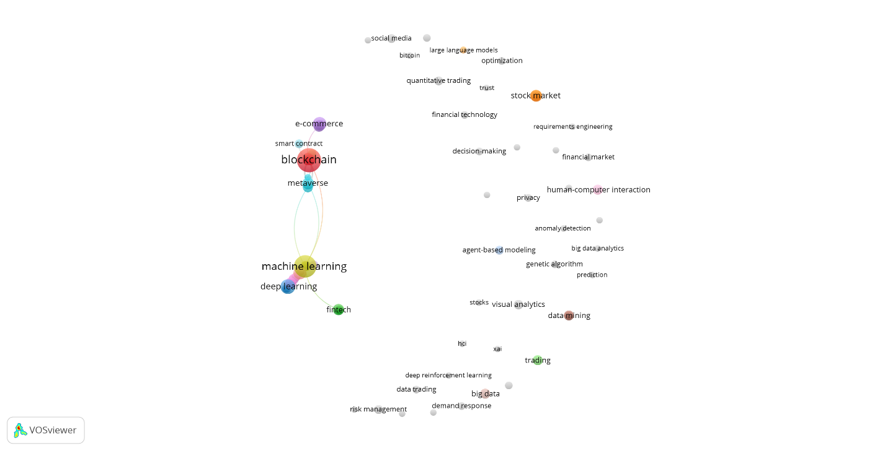
Figure 11. VOSViewer author-keyword co-occurrence network.

This figure is based on keywords chosen by the authors of the papers. The strongest keyword group centers on blockchain, smart contract, metaverse, and NFT, showing that newer digital finance technologies are an important theme in the dataset. Another major area centers on machine learning and deep learning, which connects stock market prediction and algorithmic trading. Human-computer interaction, privacy, visual analytics, and decision-making appear more separated, suggesting that UI and usability topics exist in the literature but are not as tightly connected as the technology-focused keywords.
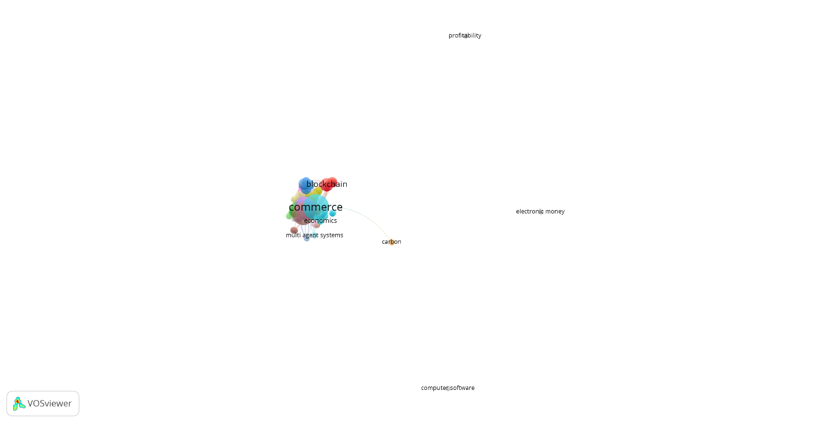
Figure 12. VOSViewer index-keyword co-occurrence network.
This figure uses Scopus index keywords rather than author keywords. The dominant terms are commerce, blockchain, electronic money, computer software, and profitability. The map suggests that Scopus categorizes much of this literature around electronic commerce and digital transaction systems, rather than only around trading-interface design. The distance between terms such as profitability and computer software shows that the dataset combines business/finance topics with technical system-development topics.


Figure 13. VOSViewer country-collaboration network.
Here it shows collaboration patterns by country, based on author affiliations. China is the largest and most central country in the network, which means it contributes the highest number of papers in this dataset. South Korea, Germany, and other countries appear close to the main cluster, suggesting collaboration or thematic similarity. Countries such as Thailand, Poland, and Ukraine appear farther away, meaning they are less connected to the main international collaboration structure in this dataset.
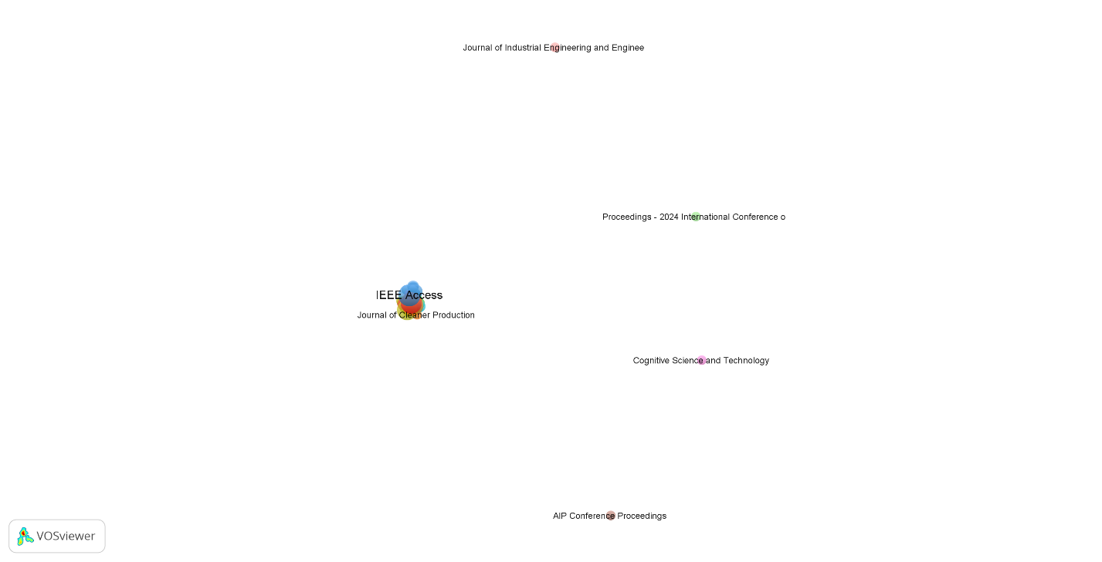
Figure 14. VOSViewer source similarity network.
Our final VOSviewer figure maps publication sources according to similarity in their keyword profiles. IEEE Access appears to be the most visible source, suggesting it is one of the main outlets for papers connected to this topic. Nearby sources such as Journal of Cleaner Production indicate overlaps in themes such as technology, systems, and sustainability. More distant sources, including AIP Conference Proceedings and Cognitive Science and Technology, show that the topic is spread across different research areas rather than concentrated in one journal or conference.
The VOSViewer maps add a graph-analytic perspective to the term-frequency results. The co-occurrence networks show clusters around financial prediction, data-driven modeling, blockchain and smart contracts, platform adoption, and human-computer interaction. The keyword maps indicate that technology-focused terms are strongly represented, while UI and usability terms are present but more dispersed. This suggests that interface design is an important part of the literature, but it is often embedded within broader research on financial systems, analytics, blockchain, or decision support.
The country and source maps also support the conclusion that the field is fragmented and international. Several countries and venues contribute to the literature, but the network does not appear to be dominated by one single research community. For a developing interdisciplinary topic, this fragmentation is expected; it also indicates an opportunity for future work to connect HCI, finance, and software-engineering perspectives more directly.

4.10 Bibliometrix Analysis
To strengthen our bibliometric analysis, the final 491-paper Data A file was analyzed directly with the R bibliometrix package. The biblioAnalysis output reports 384 publication sources, 1,553 authors, an annual growth rate of 2.98%, an average of 10.31 citations per document, and 3.58 co-authors per document. Conference papers and articles dominate the corpus, which is consistent with the applied, software-oriented nature of research on financial trading platforms.
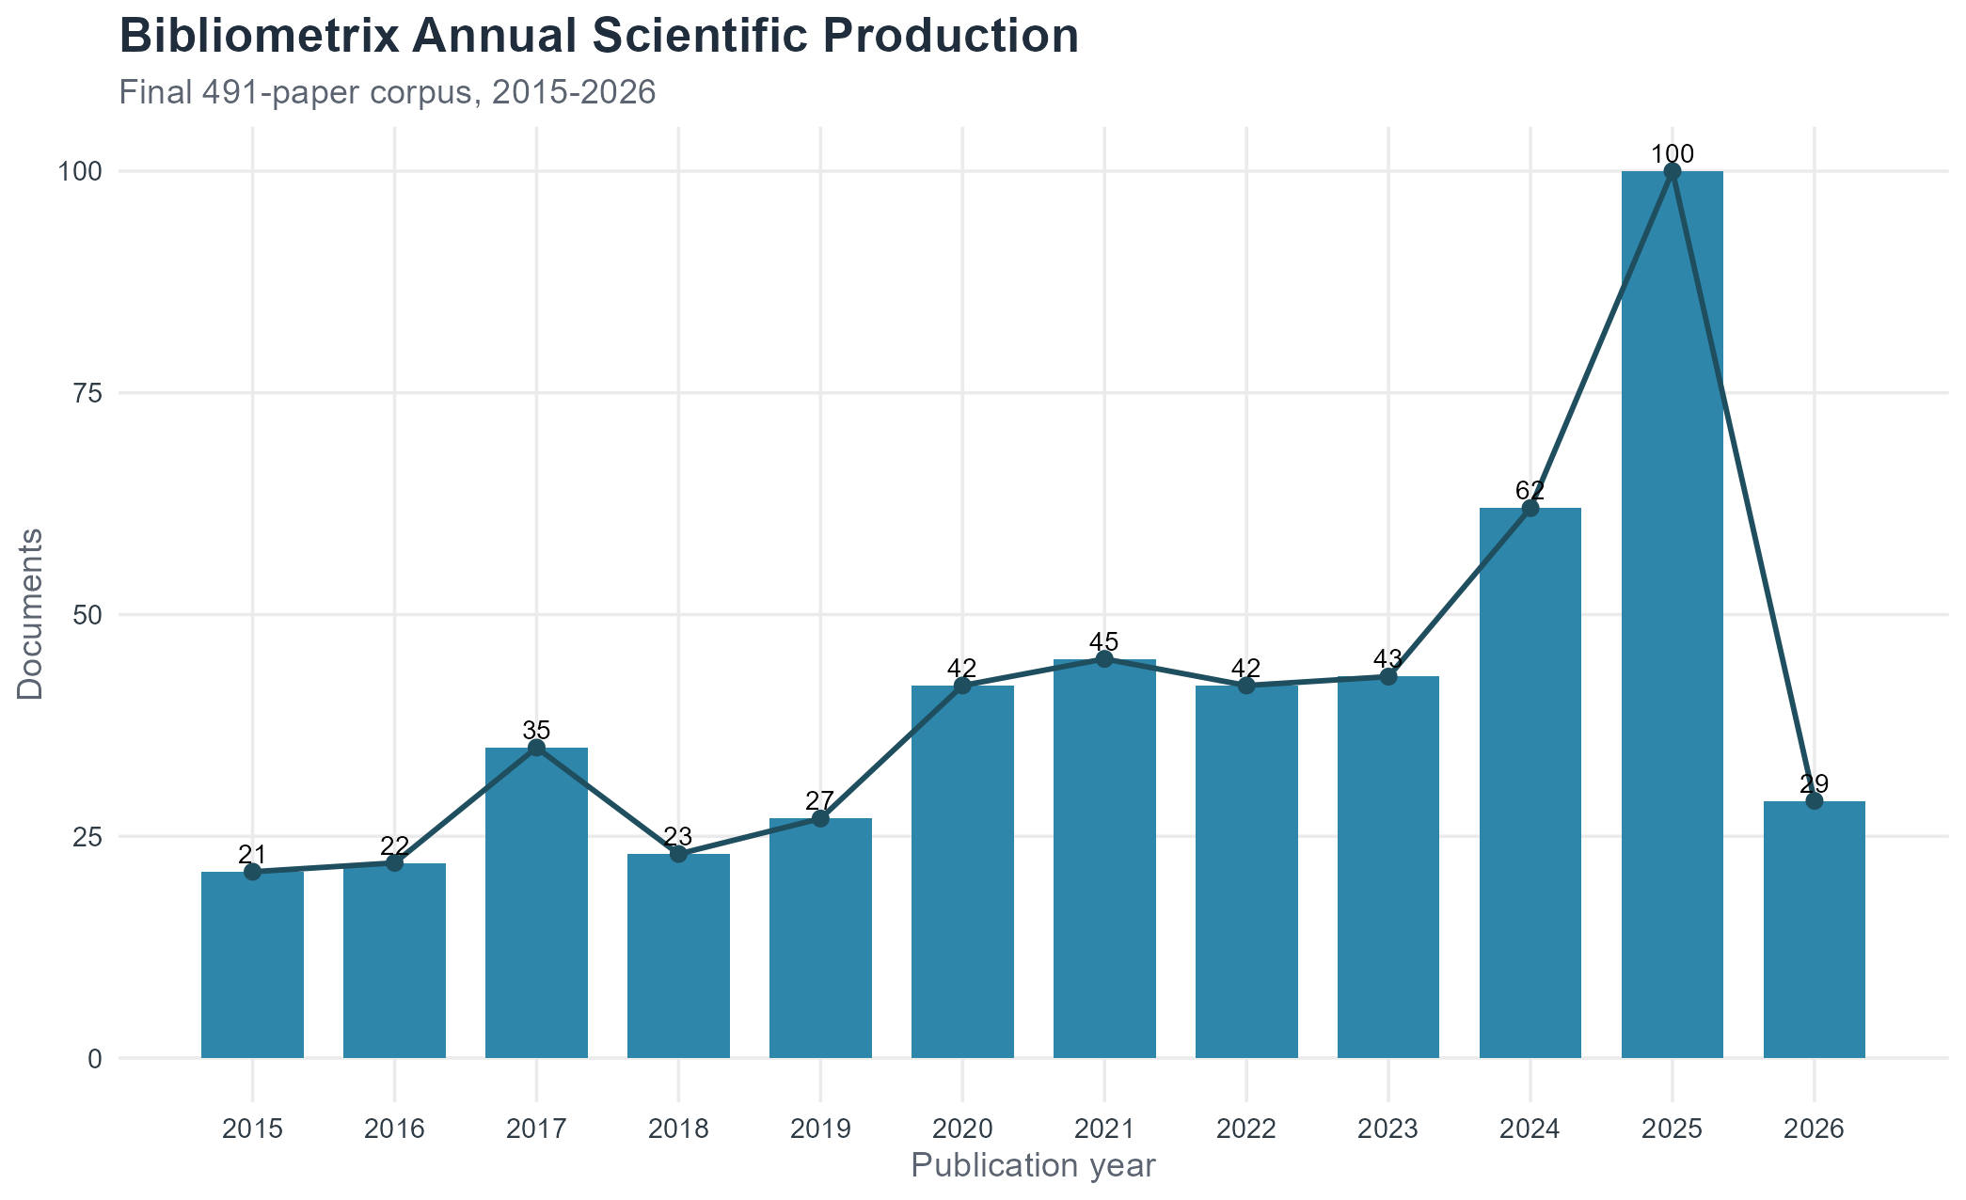
Figure 15. Bibliometrix annual scientific production for the final 491-paper corpus.
The annual-production plot shows steady growth across the study period, with the highest full-year output in 2025. This supports the conclusion that research interest in trading platforms, financial technology, blockchain, AI-assisted investment, and user-facing financial systems has accelerated in recent years. The 2026 count is lower because it represents an incomplete publication year.
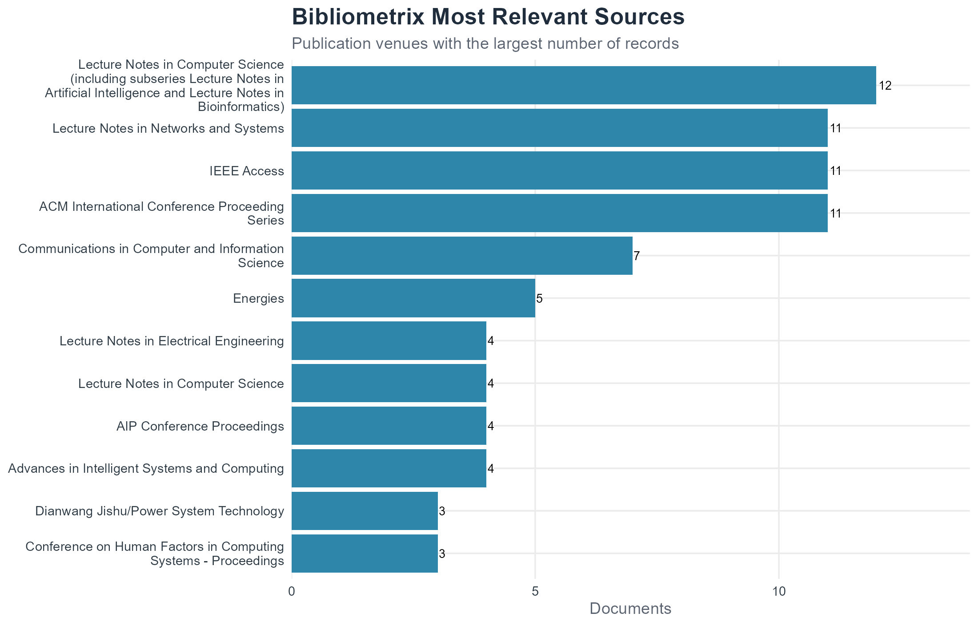
Figure 16. Bibliometrix most relevant sources.
The source-productivity results show that the literature is spread across computer science, information systems, engineering, and finance outlets. Lecture Notes in Computer Science is the largest source category with 12 records, followed closely by ACM International Conference Proceeding Series, IEEE Access, and Lecture Notes in Networks and Systems with 11 records each. This confirms that the topic is interdisciplinary and not controlled by a single journal or conference.
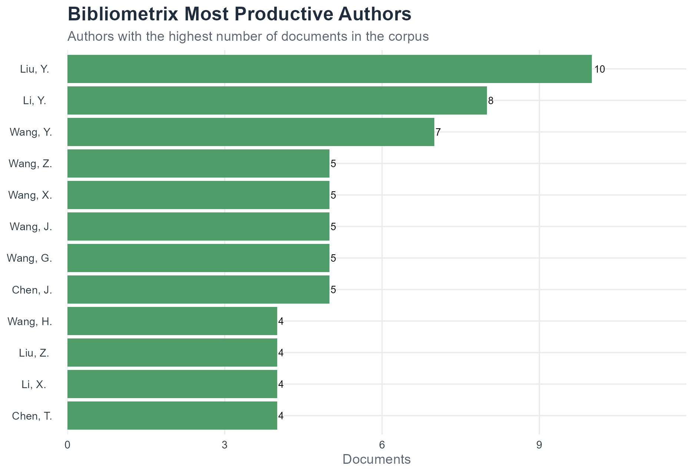
Figure 17. Bibliometrix most productive authors.
The author-productivity results show a broad authorship base rather than a small dominant group. The most productive named author is Liu, Y. with 10 documents, followed by Li, Y. with 8 and Wang, Y. with 7. The long tail of authors is consistent with an emerging interdisciplinary field where related work appears across several sub-communities.
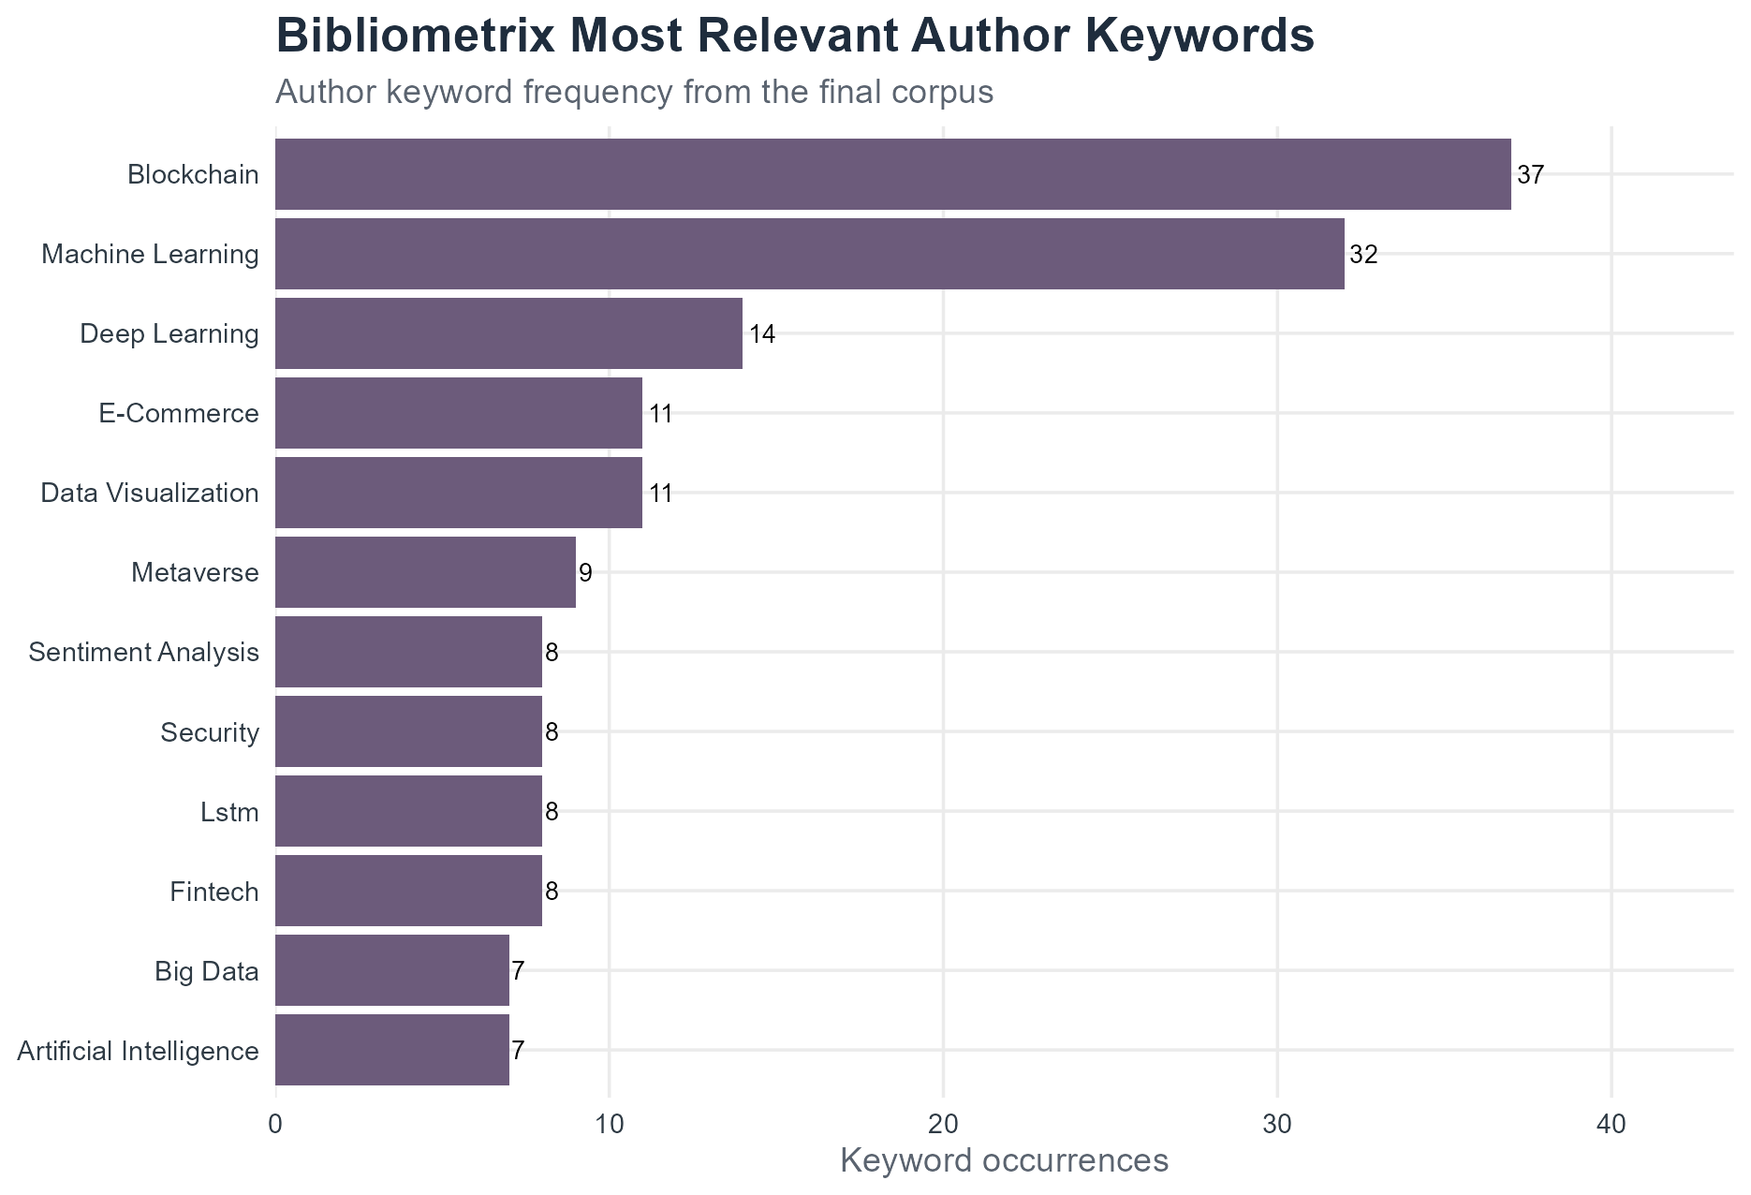
Figure 18. Bibliometrix most relevant author keywords.
The author-keyword results identify blockchain, machine learning, deep learning, e-commerce, data visualization, metaverse, sentiment analysis, security, LSTM, FinTech, big data, and artificial intelligence as recurring themes. This pattern complements the abstract-level text mining: a large part of the literature is technically oriented, but several themes connect directly to user interfaces, visualization, decision support, and financial-platform design.

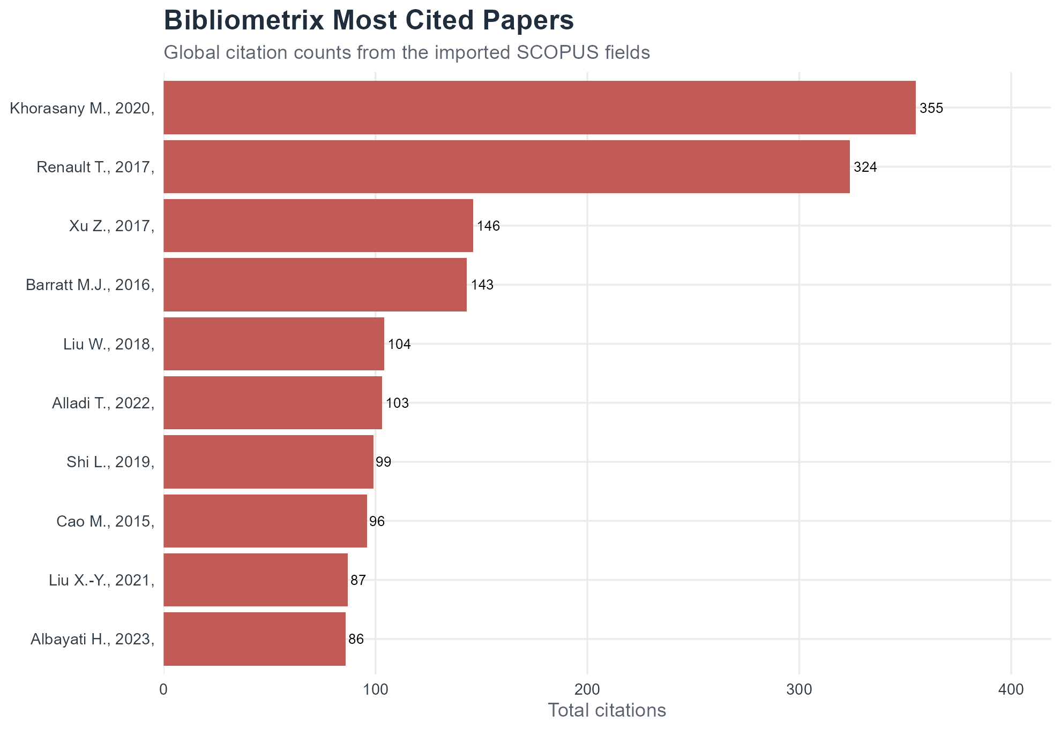
Figure 19. Bibliometrix most cited papers.
The most-cited-paper analysis shows that highly cited work often comes from adjacent areas such as energy trading, financial market prediction, blockchain, and decision-support systems. This is important for interpreting the corpus: the literature on trading-platform UI design is connected to broader technology and financial-systems research rather than existing as a separate research silo.

5. Ethical Considerations and Project Experience

5.1 Algorithmic Transparency
One major ethical issue in trading interface design is the presentation of algorithmic or AI-generated recommendations. A platform may display signals, ratings, alerts, or risk scores that look authoritative even when they are based on uncertain models. If users cannot tell how a recommendation was produced, what data it uses, or how confident the system is, they may over-trust the interface. Transparent labeling, confidence indicators, and accessible explanations are therefore important design requirements.

5.2 Interface-Induced Bias and Risk
Trading interfaces can shape behavior. One-click trading, constant notifications, bright gain/loss colors, gamified achievements, and simplified risk displays may increase impulsive decisions. Designers have a responsibility to consider whether interface features encourage informed decision-making or push users toward excessive trading. In financial contexts, usability should not mean removing every moment of reflection.

5.3 Data Privacy and Security
Trading platforms collect sensitive behavioral and financial data, including transaction histories, watchlists, search behavior, device information, and risk preferences. Privacy-by-design principles are important because misuse or leakage of this data could harm users financially and personally. Interfaces should make privacy controls clear and should avoid collecting unnecessary data simply because it is technically possible.

5.4 Accessibility and Inclusion
Accessibility is also an ethical issue. Trading interfaces often rely on dense charts, small text, red/green color coding, and rapid real-time changes. These conventions can exclude users with visual impairments, color-vision differences, older users, or users with limited financial literacy. A responsible trading platform should support readable layouts, clear labels, keyboard navigation, strong contrast, and explanations that do not assume expert knowledge.

5.5 Experience from the Project
The project showed that literature review can be strengthened by combining manual judgment with data analytics. Automated text mining made it possible to summarize hundreds of abstracts, while manual review remained necessary for removing unrelated records and interpreting the meaning of clusters. The experience also showed that search strategy matters: broad queries captured many relevant records but also introduced unrelated papers, while narrow queries produced cleaner but smaller results. A strong review therefore requires both systematic searching and careful cleaning.

6. Conclusions
This report analyzed 491 related SCOPUS publications on user interface design for financial trading platforms. The results show a research area located between financial technology and human-computer interaction. Frequent terms such as data, trading, system, market, and financial show the technical-financial core of the literature, while terms such as platform, user, design, users, and information show the interface and usability dimension.
The five required text-mining outputs produced complementary insights. The frequency chart and word cloud identified the dominant vocabulary. The heatmap showed which concepts tend to appear together. The document map showed that the corpus contains both dense thematic clusters and specialized outliers. The term map clarified the relationship between finance-oriented and interface-oriented concepts. VOSViewer and bibliometrix summaries confirmed that the topic is interdisciplinary, with visible clusters around market prediction, blockchain, decision support, information systems, and user-facing platform design.
Future research should give more direct attention to the ethical design of AI-assisted trading interfaces, accessibility for non-expert and disabled users, and empirical testing of how interface features influence financial decision-making. The field would also benefit from stronger integration between HCI researchers, financial-technology practitioners, behavioral-finance scholars, and software engineers.

7. References
Aria, M., & Cuccurullo, C. (2017). bibliometrix: An R-tool for comprehensive science mapping analysis. Journal of Informetrics, 11(4), 959-975. https://doi.org/10.1016/j.joi.2017.08.007
Davis, F. D. (1989). Perceived usefulness, perceived ease of use, and user acceptance of information technology. (“Perceived usefulness, perceived ease of use, and user acceptance of ...”) (“Perceived usefulness, perceived ease of use, and user acceptance of ...”) MIS Quarterly, 13(3), 319-340. https://doi.org/10.2307/249008
Law, E. L. C., Roto, V., Hassenzahl, M., Vermeeren, A. P. O. S., & Kort, J. (2009). Understanding, scoping and defining user experience: A survey approach. Proceedings of the SIGCHI Conference on Human Factors in Computing Systems, 719-728. https://doi.org/10.1145/1518701.1518813
Nielsen, J. (1994). Usability Engineering. Academic Press.
Silge, J., & Robinson, D. (2017). Text Mining with R: A Tidy Approach. O'Reilly Media. https://www.tidytextmining.com
Van Eck, N. J., & Waltman, L. (2010). Software survey: VOSviewer, a computer program for bibliometric mapping. Scientometrics, 84(2), 523-538. https://doi.org/10.1007/s11192-009-0146-3
Adadi, A., & Berrada, M. (2018). Peeking inside the black-box: A survey on explainable artificial intelligence. IEEE Access, 6, 52138-52160. https://doi.org/10.1109/ACCESS.2018.2870052
Fang, Y., Lim, K. H., Feng, Y., & Lim, E. T. K. (2012). A comprehensive study of the relationships between usability dimensions and user satisfaction. Pacific Asia Conference on Information Systems.

Appendices

Appendix A: Final Data Files Included
- Data_A_final_cleaned_related_papers.xlsx: Data A final: 491 related papers after deduplication and manual removal
- Data_B_final_paperid_abstracts_only.xlsx: Data B final: PaperID and Abstract for 491 papers
- Removed_manual_review_unrelated_entries.xlsx: 20 manually reviewed records removed from the final corpus
- final_report_assets/figures: All figures used in the corrected report
- final_report_assets/tables: Supporting CSV/XLSX tables and coordinates
- BANA420_project_analysis_fixed.Rmd: R Markdown analysis file from the project folder

Appendix B: Search Query Counts
- Search 1: papers 8
- Search 2: papers 4
- Search 3: papers 36
- Search 4: papers 136
- Search 5: papers 28
- Search 6: papers 1
- Search 7: papers 83
- Search 8: papers 5
- Search 9: papers 55
- Search 10: papers 45
- Search 11: papers 21
- Search 12: papers 5
- Search 13: papers 2
- Search 14: papers 4
- Search 15: papers 16
- Search 16: papers 2
- Search 17: papers 5
- Search 18: papers 32
- Search 19: papers 3

Appendix C: Top 20 Terms
- Term data: frequency 881
- Term trading: frequency 826
- Term market: frequency 484
- Term financial: frequency 482
- Term system: frequency 479
- Term model: frequency 314
- Term analysis: frequency 312
- Term platform: frequency 305
- Term user: frequency 297
- Term design: frequency 289
- Term users: frequency 281
- Term stock: frequency 275
- Term energy: frequency 258
- Term information: frequency 252
- Term research: frequency 233
- Term learning: frequency 214
- Term performance: frequency 214
- Term experience: frequency 191
- Term platforms: frequency 186
- Term technology: frequency 185

Appendix D: Software and Packages
The analysis used spreadsheet processing, text mining, TF-IDF weighting, multidimensional scaling, VOSViewer visualizations, and the R bibliometrix package. The bibliometrix outputs are saved under final_report_assets/bibliometrix and include the converted bibliometrix input file, bibliometrix_summary.txt, annual scientific production, most relevant sources, most productive authors, most relevant keywords, and most cited papers. R packages referenced in the project workflow include dplyr, readr, readxl, openxlsx, stringr, tidyr, purrr, tibble, janitor, tidytext, widyr, ggplot2, ggrepel, Matrix, wordcloud, RColorBrewer, scales, and bibliometrix.

